We know the coming days and weeks are going to be difficult for families across the UK, as the spread of Covid-19 causes schools to close. As the experts in developing skills and bringing adventure to young people, we want to do what we can to help.
While we normally love the great outdoors, we’ve pulled together some inspired indoor activity ideas (if we do say so ourselves). Keep your kids learning new skills and having fun (and avoid hearing ‘I’m bored’ every 30 seconds) all in #TheGreatIndoors.
Snap happy
Learn how to use a camera, and share your skills with others.
Suitable for: 8-10s | Takes: 30 mins
Snap happy >
Storm in a teacup
Understand energy by creating your own tornado.
Suitable for: 8-10s | Takes: 20 mins
Storm in a teacup >
Ways to be kind to yourself
Five ways to be kind to yourself with mindfulness and self care (even if you don't really feel like it).
Suitable for: Everyone
How to beat the winter blues >
Teeny tiny twig rafts
Build a miniature raft with twigs and leaves, then set sail. Will yours float successfully away?
Suitable for: 8-10s | Takes: 30 mins
Teeny tiny twig rafts >
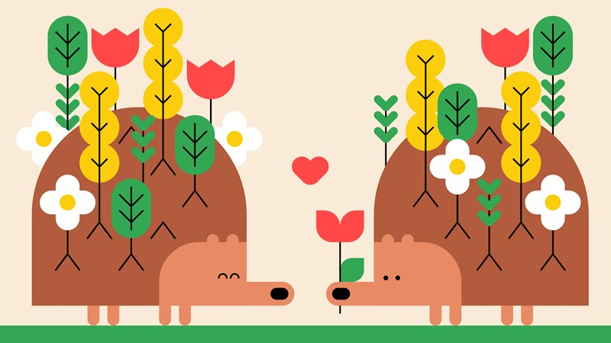
The leafy hedgehog
Get crafty with natural materials to create a leafy hedgehog of your own.
Suitable for: 6-10s | Takes: 20 mins
The leafy hedgehog >
Lolly stick catapults
Put your pioneering skills to the test by creating a miniature catapult from lolly sticks.
Suitable for: 6-10s | Takes: 25 mins
Lolly stick catapults >
Be a blackout poet
Anyone can be a poet (even if they don’t know it). Set your inner poet free!
Suitable for: 10-14s | Takes: 30 mins
Be a blackout poet >
Leaf animals
Look at leaves in a different way and use them to make an animal collage.
Suitable for: 6-8s | Takes: 50 mins
Leaf animals >
Switch off challenge
Take on the switch off challenge to find a healthy balance between time on and away from screens.
Suitable for: 10-18s | Takes: 15 mins
Switch off challenge >
Mark my words
Never lose your place in a book again, thanks to this monster bookmark.
Suitable for: 6-8s | Takes: 20 mins
Mark my words >
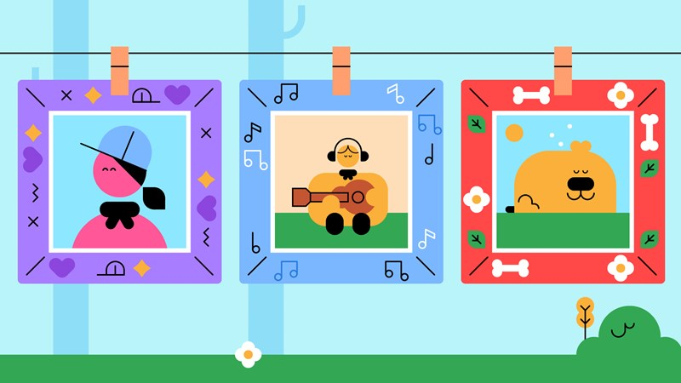
Fabulous fancy frames
Craft a frame for a photograph that makes you smile then make a gallery for everyone to admire.
Suitable for: 6-8s | Takes: 45 mins
Fabulous fancy frames >
Dear future me
What does the future hold? Use your imagination to send a postcard to your future self.
Suitable for: 6-8s | Takes: 10 mins
Dear future me >
An in-tents year
Get creative and make a colourful calendar to show off your best photos.
Suitable for: 8-10s | Takes: 1 hr
An in-tents year >
Weekly wins
Make diaries to record little victories, as we work out what wins do for our wellbeing.
Suitable for: 10-14s | Takes: 25 mins
Weekly wins >
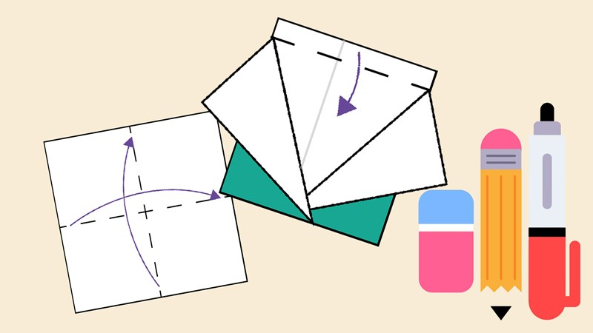
To foldly go
Fold for fun in this traditional origami challenge and design your own outfit.
Suitable for: 10-18s | Takes: 25 mins
To foldly go >
Changing your coat
Understand your local coat of arms, then make your own shield.
Suitable for: 8-10s | Takes: 1 hr
Changing your coat >
More activities to do at home
There are over 100 more activities for you to do with your little ones over the coming weeks. Check them out here.
Find more activities
In partnership with Nominet.
In partnership with Rolls-Royce.

The Scouts
- National volunteering vacancies
- Paid job vacancies
- Key policies
- Reports
- Brand centre

Websites
- Scout Store
- Scout Adventures
- Unity Insurance Services
- World Scouting
- World Scout Shop
- Scouts Scotland
- Scouts Cymru
- Scouts NI

Contact us
- info.centre@scouts.org.uk
- 0345 300 1818
- Open 9am-5pm Monday to Friday
- Find us...
© Copyright The Scout Association 2020. All Rights Reserved.
Charity numbers: 306101 (England and Wales) and SC038437 (Scotland).
Registered address: The Scout Association, Gilwell Park, Chingford, London, England E4 7QW
Website Terms and Conditions, Data Protection and Privacy Policy
Last build at 4:01:19 PM on 19.03.2020

